Students Testimonials
Mr. Saif Saad Fakhrulddin
PhD Scholar

I chose to pursue a PhD in Biomedical Science at Gujarat Technological University's School of Applied Science and Technology. One of the SAST's strengths is its faculty, who have experience in a variety of fields and are actively engaged in research. The design of the coursework here is excellent for passing any competitive exam and is also beneficial for gaining academic and engineering experience. The study environment is competitive, which has helped me to grow and become more competent. At the end, I’m appreciated for SAST-GTU to give me this opportunity to complete my research study and finish my work in the field of Biomedical engineering.

Bhumi Rajguru
PhD Scholar

As a PhD student, I believe that practicals and research are given a lot of importance, which is a wonderful thing because it provides us with a great learning opportunity. The nicest part is that the professors encourage hard work, make us more self-reliant, and expose us to all areas of the subject. The faculty have immense knowledge to pass forward and moreover very open to talk to for any queries. Thanks to SAST GTU for providing opportunities to be involved in many promising research project and workshop. I am very appreciative for SAST academic and teaching training.

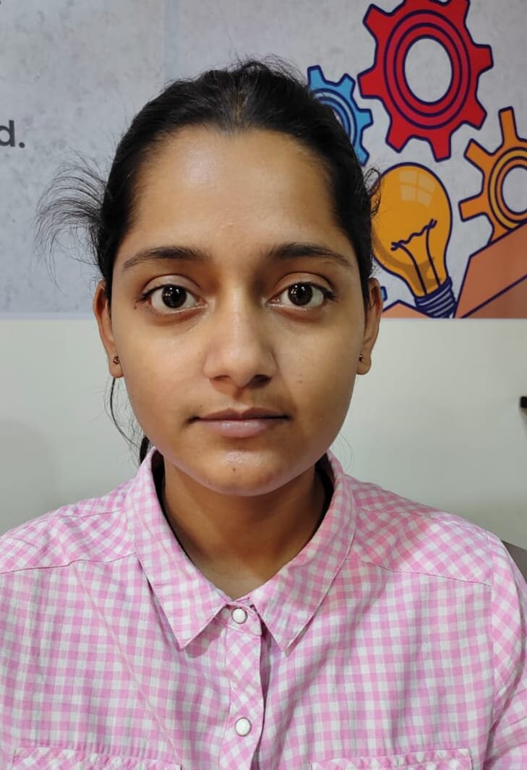
Saumya Singh
Student, II sem
MSc Industrial Biotechnology

I would like to express my sincere gratitude to School of Applied Sciences and Technology (GTU) for helping me at each and every step and it is providing the best possible platform to excel in my career.

Bhavika Parekh
Student, II sem
MSc Industrial Biotechnology

Learning is the essence of life. Studying in the SAST -GTU had been good place where I met so many staff and helpful faculties who encouraged me and enhanced my skills to enlighten my life. It's truly a blessing experience.

Raj Doshi
Student, II sem
MSc Industrial Biotechnology

It’s been a great experience so far. I have found the professors and staff to be incredibly friendly and helpful as I am working on getting my degree. The curriculum of my major in Industrial Biotechnology has good structure which can give me the real experience for the field I desire to get into. They have helped me a lot in many ways. I really like this (SAST) school of applied sciences because I can get the exposure I want.
-
Mihir Mistry
Student, II sem
MSc Industrial Biotechnology

The environment of school of Applied Sciences and Technology (GTU) helping me a lot to excel in my field. Proud to be part of SAST -GTU.

